## 

## 

**Course:** COMP2477- WA - Object-Oriented Programming

**Final Project:**

Conference Registration Fee Calculator

**GROUP-12**

**Student Name:**

Abhijeet Singh [1207508]

Kirtan Sukhadiya [1222983]

**Date:** March 28th, 2025

## 

## 

## 

## **Conference Registration Fee Calculator - Report**

### **1. Introduction**

The **Conference Registration Fee Calculator** is a JavaFX-based application designed to facilitate conference registration by allowing users to select their registration type and optional add-ons. The application dynamically calculates and displays the total registration fee in a separate window upon form submission. This report elaborates on the application's features, implementation, and functionality, providing a comprehensive understanding of its workings.

### **2. Features**

The application provides the following key functionalities:

* **Registration Types:**
  + General Registration: $895
  + Student Registration: $495
* **Optional Add-Ons:**
  + Opening Night Dinner: $30
* **Preconference Workshops:**
  + Introduction to E-commerce: $295
  + The Future of the Web: $295
  + Advanced Visual Basic: $395
  + Network Security: $395
* **Dynamic Calculation:**
  + Real-time fee calculation based on user selections.
* **Input Validation:**
  + Optional features are only enabled after selecting a registration type.
* **Total Fee Display:**
  + The total registration cost is shown in a new window after closing the selection form.

### **3. Implementation Details**

The application is implemented using **JavaFX** and adheres to the JavaFX Application lifecycle. Key components include:

#### **3.1 Graphical User Interface (GUI)**

* Built using **VBox** and **HBox** layouts to structure the form.
* **Radio Buttons** for selecting registration types.
* **CheckBoxes** for optional add-ons and workshops.

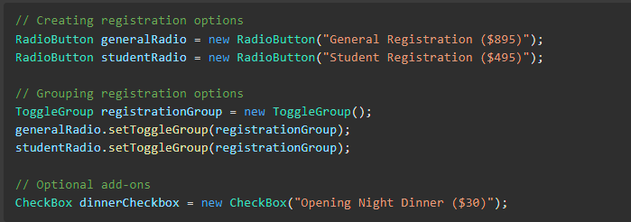

#### **3.2 Event Handling**

* **ToggleGroup** ensures only one registration option can be selected at a time.
* Event listeners monitor user inputs and dynamically update the total fee.
* Optional add-ons are disabled until a registration type is chosen.

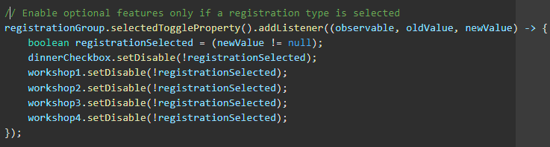

#### **3.3 Fee Calculation**

* The calculateTotal() method computes the total cost based on the user's selections.

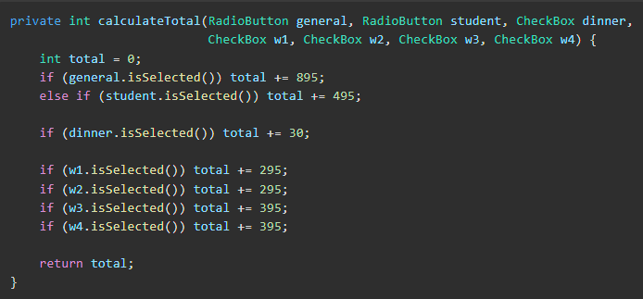

* Upon clicking the **Close** button, the form closes, and a new window displays the total fee.

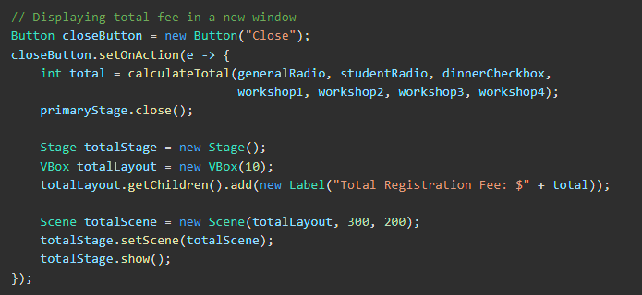

### **4. Code Structure**

The code is organized in the following way:

1. **Application Entry Point:**
   * The main() method launches the JavaFX application.



1. **start() Method:**
   * Sets up the primary window (stage) with registration and add-on options.
   * Initializes UI components (radio buttons, checkboxes, labels, and buttons).
   * Configures event listeners to dynamically manage UI states and calculate fees.
2. **calculateTotal() Method:**
   * Calculates the total registration fee by summing up selected options.
3. **Secondary Stage:**
   * When the **Close** button is pressed, a secondary window displays the calculated fee.
4. **Dynamic UI Behavior:**
   * When the user selects a registration type, optional features (dinner and workshops) are enabled.
   * The UI updates in real-time as selections are made, providing an interactive experience.
5. **Application Flow:**
   * User interaction triggers real-time updates, enhancing the user experience and minimizing errors.

### **5. Functionality Walkthrough**

1. **Startup:**
   * The application launches a window with registration options and add-ons.
2. **User Input:**
   * Users choose either **General** or **Student** registration.
   * Optional features (Dinner and Workshops) become available.
3. **Dynamic Calculation:**
   * As users select add-ons, the fee is recalculated.
4. **Submission:**
   * Clicking **Close** triggers a new window displaying the total fee.

### **6. Example Calculation**

Consider the following user selections:

* General Registration: $895
* Opening Night Dinner: $30
* The Future of the Web Workshop: $295

**Total Fee: $1,220**

If all options are selected under **General Registration**, the total would be:

$895 + $30 + $295 + $295 + $395 + $395 = $2,305

**7. Screenshots**



### 

### 

### 

### 

### 

### 

### 

### 

### 

### 

### 

### 

### 

### 

### 

### 

### 

### 

### 

### **8. Conclusion**

The **Conference Registration Fee Calculator** provides a seamless and interactive user experience by dynamically calculating the registration fee based on user inputs. The application's structure, built using **JavaFX**, demonstrates efficient event handling and robust input validation.